DA 6823

Kilger

Module 3: Part #2 (15 points)

**Dependent Samples t test**

**General Instructions:** In your own words, answer each of the following questions - don’t copy (e.g. cut and paste) some definition out of a book word for word. This is not a group project – you are expected to complete this module on your own. You may refer to text books, online or other sources but not your fellow classmates. If you don’t understand the question, feel free to ask the instructor in class, in office hours or in an email.

Here is the SAS printout for an dependent samples ttest that compares advertising receptivity (scale =person has low ad receptivity, 5=person has high ad receptivity) before and after the person drinks a shot of tequila.

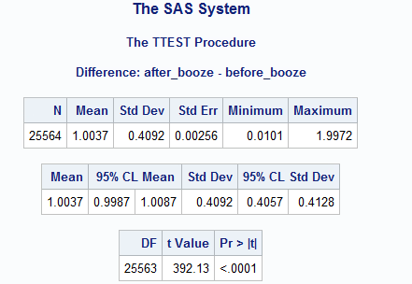

1. **State the null and alternative hypotheses for the dependent sample t test. (4 points)**

**Null:** The difference between the mean after_booze and before_booze advertising receptivity is equal to 0.

**Alternative:** The difference between the mean after_booze and before_booze advertising receptivity is not equal to 0.

1. **Name one assumption of the dependent sample t test ( 2 points)**

Normal distribution (approximately) of the difference between the paired values

1. **What is the difference in the before and after alcohol means? (2 points)**

The average difference between a person’s after_booze and before_booze advertising receptivity. On average, the person had a **1.0037**-unit difference between after_booze and before_booze advertising receptivity.

1. **What can you conclude about the change in advertising receptivity due to the application of alcohol to a respondent? (4 points)**

In the table with the actual paired t test results, the p-value is very small (**p < .0001**), so we **reject the null hypothesis** that the average after_booze and before_booze advertising receptivity were the same and conclude that the **after_booze advertising receptivity had a significantly different average** than the before_booze advertising receptivity.

1. **Why is this called a “paired” or dependent sample t test? (3 points)**

The Paired Samples t Test compares the means of two measurements taken from the same individual, object, or related units. These are referred to as "paired" measurements. The purpose of this test is to determine whether there is statistical evidence that the mean difference between paired observations is significantly different from zero.